Chapter 2. Knowledge and Reasoning
Table of Contents

Chapter 2. Knowledge and Reasoning
A maintenance robot is sent into a building with four rooms. Somewhere inside, one room has a gas leak, but the robot is never told which one. Its only tool is a sensor that reports a smell whenever the robot stands in a room next to the leak. The robot walks into the first room and senses nothing. It moves to a second room and the sensor reports a smell. Moments later the robot announces, with complete confidence, exactly which room holds the leak, and it does this without ever entering that room.
How did it know?
The robot was not given the answer. It combined a few things it did know, that there was no smell in the first room, that there was a smell in the second, and a rule about how smell relates to a nearby leak, and from these it derived a fact that no one had supplied. This ability, to hold some knowledge and squeeze out of it a conclusion that was never stated directly, is the subject of this chapter.

2.1 From Searching States to Searching Conclusions
The previous chapter gave an agent one great power. Faced with a start, a goal, and some actions, it could search through the space of possible situations until it found a path to the goal. That agent was powerful, but in a narrow way. It could find its way to a place, but it could not reason about facts. It could not take “there is no smell here” and “smell means a leak is next door” and put them together to conclude “the leak is over there”.
This chapter adds that second power. An agent will now store knowledge and use it to derive new knowledge. The link between the two chapters is worth stating at the outset, because it runs through everything that follows.
Chapter 1: search through possible states
|
Chapter 2: search through possible conclusions
|
inference
|
intelligent reasoning
In Chapter 1 the agent searched a space of locations and actions. In this chapter the agent searches a space of statements, rules, substitutions, and possible conclusions. The activity is the same, a disciplined exploration toward a goal, but the terrain has changed from a map to a body of knowledge. Keeping this parallel in mind makes the new material feel familiar rather than foreign, and the idea that inference is a form of search will return at several points.

2.2 Knowledge-Based Agents
To reason, an agent needs somewhere to keep what it knows and a way to work with it. That is what a knowledge-based agent provides.
An agent, as established in Chapter 1, is a system that perceives its environment and acts upon it. Knowledge is information about the world stated in a form the agent can use, for example the fact that two rooms are next to each other, or the rule that a smell indicates a nearby leak. A knowledge base is the collection of all such statements the agent currently holds. A knowledge-based agent is then an agent whose decisions are driven by reasoning over its knowledge base rather than by fixed instructions alone.
It is worth being clear about how a knowledge base differs from an ordinary store of data, because they can look similar. A database records facts and returns exactly what was put into it. Ask a database for a stored value and it gives that value back. A knowledge base does more. It holds facts and rules, and when asked a question it can return conclusions that were never stored, by combining what it holds through logical steps. A database answers “what did I record?”. A knowledge base answers “what follows from what I recorded?”. That extra step, deriving the unstated, is the whole point.
A knowledge-based agent works in a repeating cycle, shown in Figure 2.1. It perceives the world, tells its knowledge base what it just observed, asks the knowledge base what should be done or what can be concluded, infers new facts as part of answering, and finally acts.
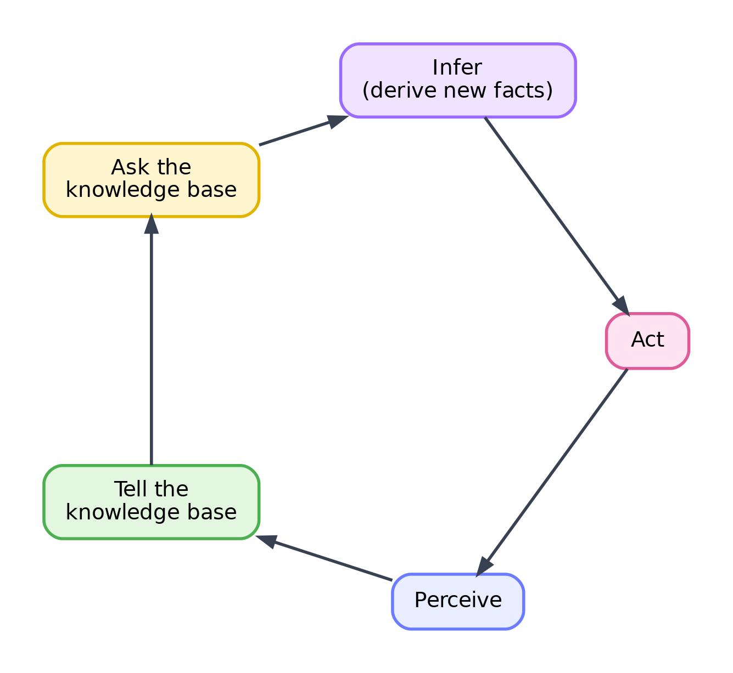
Figure 2.1. The cycle of a knowledge-based agent. Each new percept is added to the knowledge base, the agent queries the base, inference fills in what follows, and the agent acts.
Two operations carry most of the weight in this cycle, and both have standard names. To Tell the knowledge base means to add a new sentence to it, usually a fresh percept, such as “there is a smell in this room”. To Ask the knowledge base means to pose a query, such as “is the next room safe?”, and to receive an answer that may require inference to produce. A short everyday version makes the cycle concrete. A doctor perceives a patient’s symptoms, records them in memory alongside general medical knowledge, asks which illness is consistent with them, reasons to a diagnosis that was never written on the patient’s chart, and then acts by prescribing treatment. The same shape, perceive, tell, ask, infer, act, describes both the doctor and the robot.
The step that turns knowledge into a decision is inference. Once the agent can derive “the next room is safe”, acting on it, moving there, is straightforward. The difficult and interesting work is the deriving, and the rest of the chapter is about how it is done.

2.3 A Reasoning World to Return To
Throughout the chapter a single small world will serve as a running example, so that each new idea is introduced on ground the reader already understands rather than on a fresh and unfamiliar problem. It is the building the robot was sent into.
There are four rooms, named A, B, C, and D, connected as the sides of a square, so that A is next to B and C, D is next to B and C, and the two diagonal pairs are not directly connected. One room hides a gas leak. A room that is next to the leaking room smells; a room that is not next to it does not. The robot can sense smell in whatever room it currently occupies, and it can remember which rooms it has already stood in, which are certainly leak-free because it survived them. Figure 2.2 shows the world together with the reasoning the robot performs.
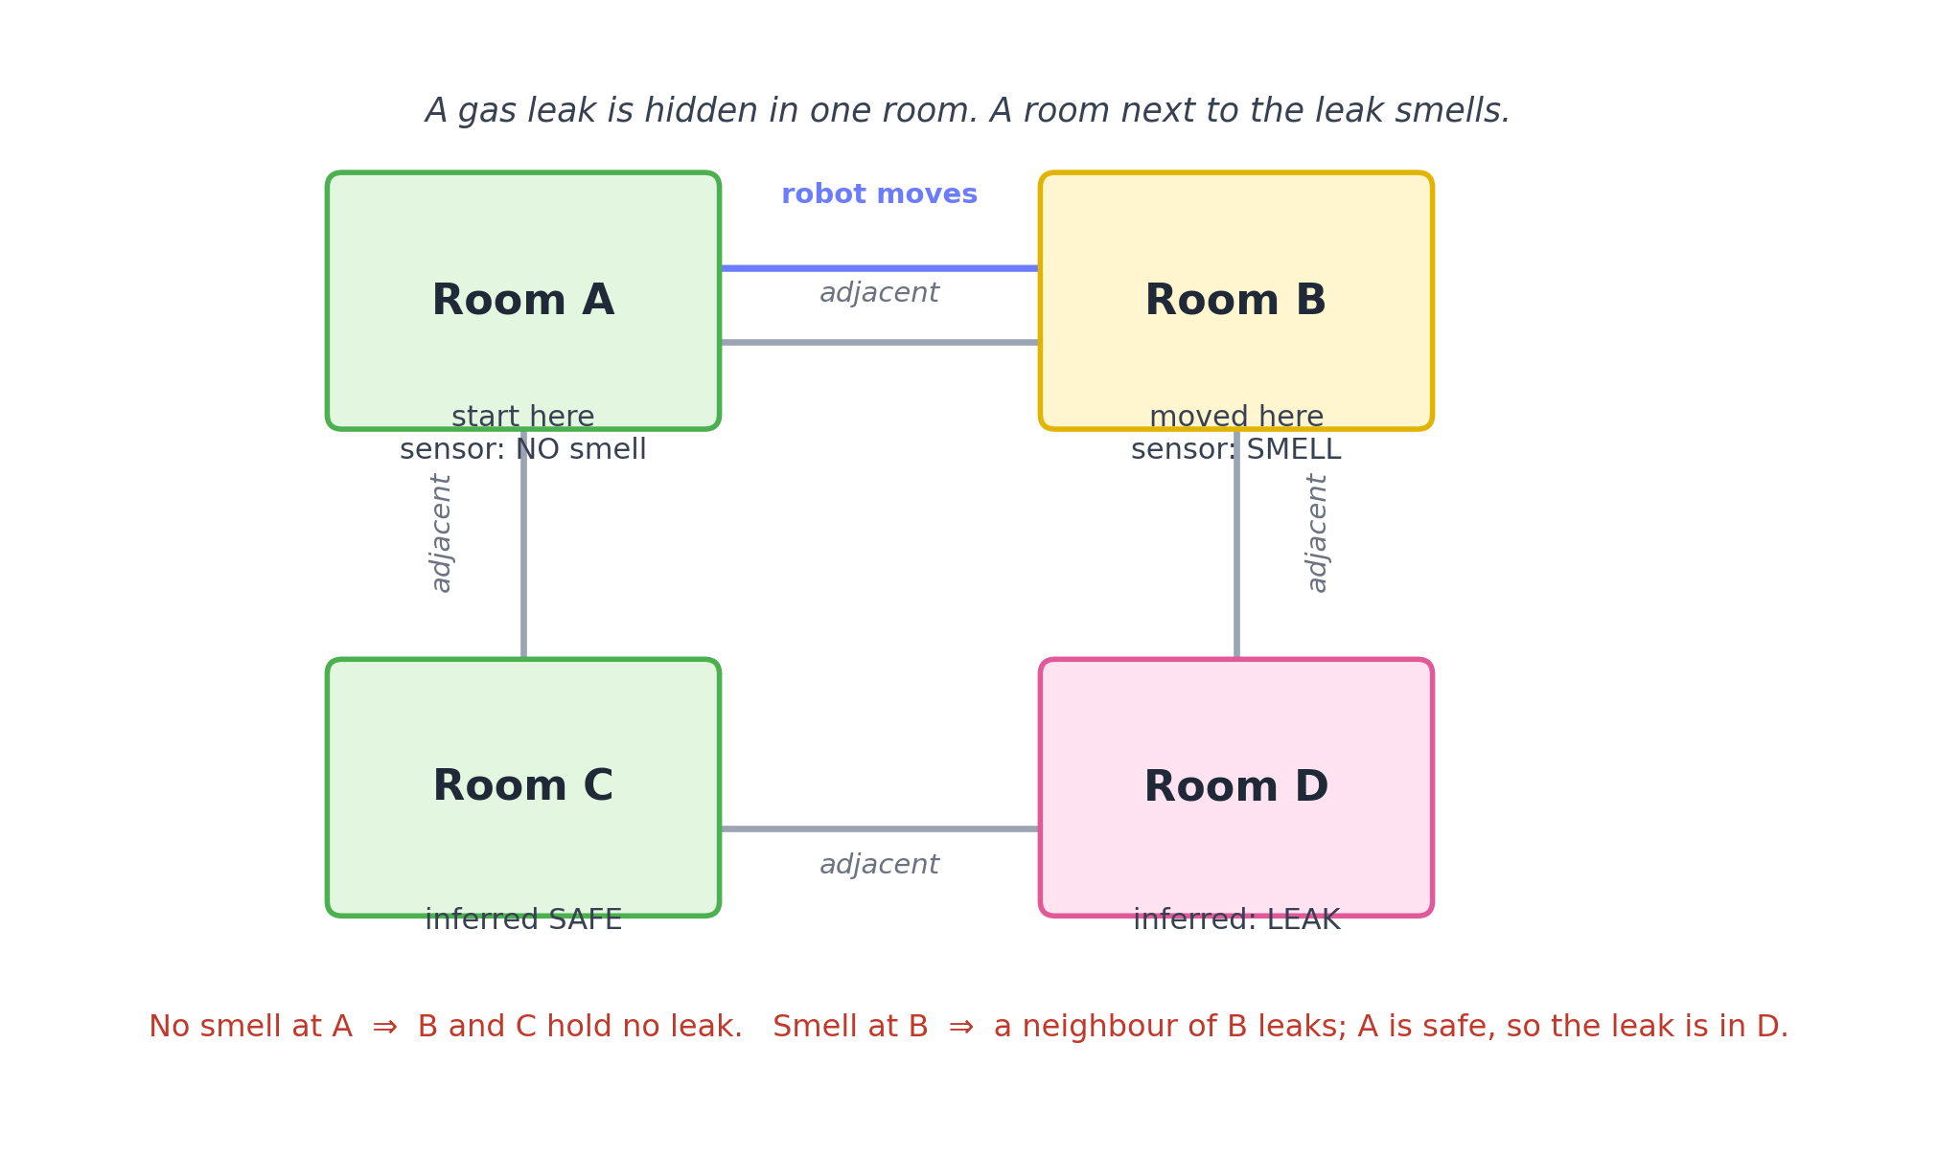
Figure 2.2. The reasoning world. The robot starts in A and senses no smell, then moves to B and senses a smell. From these two observations and the rule connecting smell to a nearby leak, it concludes that the leak is in D and that C is safe.
The chain of reasoning is short but genuine. The robot starts in room A and senses nothing. Since a room next to the leak would smell, and A does not, neither of A’s neighbours, B and C, can hold the leak. The robot then moves to B, which it now knows is safe, and senses a smell. Something next to B is leaking. The neighbours of B are A and D. Room A is known to be safe, so by elimination the leak must be in D. Along the way the robot has also learned that C is safe. None of these conclusions, “the leak is in D”, “C is safe”, were ever supplied to the robot. Each was derived.
This is exactly the behaviour promised in the opening. The task now is to build the machinery that lets a computer carry out such reasoning reliably, starting with a precise language for writing the facts and rules down.

2.4 Representation, Reasoning, and Logic
Before an agent can reason, its knowledge must be written in a form that supports reasoning. This is the problem of knowledge representation, and it turns out to demand more care than it first appears.
Consider the sentence “there is no smell in room A”. A human reads it and understands it at once. A computer needs the sentence expressed so precisely that a mechanical procedure can act on it without any human judgement. Knowledge representation is the study of how to do this: how to state facts, rules, and general statements in a language with fixed, unambiguous meaning.
A few terms describe the pieces of such a language, and each is best met through the reasoning world rather than as a bare definition. A fact is a statement taken to be true in the situation at hand, such as “there is no smell in A”. A rule is a general statement that lets one fact produce another, such as “if a room has no smell, then its neighbours have no leak”. A sentence, in the logical sense, is any statement that is either true or false, whether a simple fact or a rule. The knowledge base is a collection of such sentences.
To speak about whether sentences are true, logic uses the idea of a model. A model is one complete way the world could be, one full assignment of true or false to every basic statement. In the reasoning world, one model has the leak in D and no smell in A; another has the leak in A and a smell in B; and so on for every possible arrangement. Each model is a candidate reality. An interpretation is the meaning attached to the symbols, the agreement that the symbol standing for “leak in D” is true exactly in those models where D really does hold the leak. With models in hand, the central idea of the whole chapter can be stated. A set of sentences entails another sentence when the second is true in every model in which the first are all true. Entailment, written with the symbol $⊨$, is the precise meaning of “follows from”. When the knowledge base entails “the leak is in D”, it means that in every possible world consistent with what the robot has observed, the leak is in D, so the conclusion is forced.
Entailment describes what follows in principle. Inference is the actual process, the mechanical procedure, that derives sentences from other sentences. The distinction matters. Entailment is about truth across all models; inference is about the steps a machine takes. We want the machine’s inference to line up with entailment, and two properties describe how well it does. An inference procedure is sound when everything it derives is genuinely entailed, so it never produces a false conclusion from true premises. It is complete when it can derive everything that is entailed, so it never misses a valid conclusion. Soundness is the promise of no mistakes; completeness is the promise of no gaps. A good reasoning system aims for both.
One distinction deserves to be drawn sharply, because confusing its three parts is a frequent source of error.
Key idea. Keep separate three different things: what is actually true in the world, what the agent knows, and what logically follows from what the agent knows. The robot may not know where the leak is at the start, even though the leak is somewhere definite. As it gathers observations, what follows from its knowledge grows, until the location of the leak, though never observed directly, follows from what it knows. Reasoning is the movement from the second of these to the third.

2.5 Propositional Logic
The reasoning world now needs a written language. The simplest logic that will serve is propositional logic, and it is worth seeing why a formal language is needed at all before meeting its symbols.
Ordinary language is ambiguous. The word “or” sometimes allows both possibilities and sometimes only one; “if” carries shades of cause and time that a machine cannot be trusted to guess. To reason mechanically, the meaning of every connecting word must be pinned down exactly. Propositional logic does this for a small set of connectives, and that precision is what makes automatic reasoning possible.
The basic unit is a proposition, a statement that is either true or false and nothing in between. In the reasoning world, “there is a smell in B” is a proposition, and it will be written $Smell(B)$. The two values a proposition can take, true and false, are called Boolean values, after George Boole, who first treated logic as a kind of algebra. A proposition that cannot be broken into smaller statements, such as $Smell(B)$ or $Leak(D)$, is called an atomic proposition. Larger statements are built from atomic ones using connectives, and are called compound propositions. Figure 2.3 shows this structure.
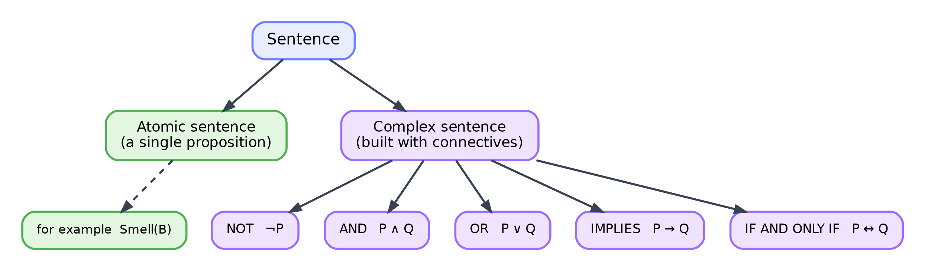
Figure 2.3. The structure of propositional logic. A sentence is either atomic, a single proposition, or complex, built from smaller sentences using the connectives not, and, or, implies, and if and only if.
There are five connectives to learn. Each is introduced the same way: first an ordinary statement, then its symbol, then its meaning, then the table that fixes its behaviour, then the reason the table looks as it does.
The connective not, written $¬$, reverses truth. The statement “there is no smell in A” is written $¬Smell(A)$. It is true exactly when $Smell(A)$ is false. The table has one input column and one output column.
P | ¬P
true | false
false | true
The connective and, written $∧$, joins two statements into one that holds only when both hold. “There is a smell in B and the leak is in D” is $Smell(B)∧Leak(D)$. It is true only in the single case where both parts are true.
P | Q | P ∧ Q
true | true | true
true | false | false
false | true | false
false | false | false
The connective or, written $∨$, produces a statement that holds when at least one part holds. “The leak is in C or the leak is in D” is $Leak(C)∨Leak(D)$. It is false only when both parts are false. This is the inclusive sense of “or”; it also allows both to be true, which differs from casual speech, where “or” often means one or the other but not both.
P | Q | P ∨ Q
true | true | true
true | false | true
false | true | true
false | false | false
The connective implies, written $→$, expresses “if, then”. “If there is no smell in A, then the leak is not in B” is $¬Smell(A)→¬Leak(B)$. Its table is the one that surprises newcomers, so it is worth reading slowly. The statement $P→Q$ is false in exactly one situation, when $P$ is true but $Q$ is false, that is, when the promise is made but broken. In every other case it counts as true.
P | Q | P → Q
true | true | true
true | false | false
false | true | true
false | false | true
The two bottom rows, where $P$ is false, are the ones that puzzle people. If there is a smell in A, then the rule “if no smell in A, then no leak in B” simply does not apply, and a rule that does not apply is not thereby broken, so it counts as true. An implication only makes a claim when its condition holds; when the condition fails, the implication makes no claim and so cannot be false.
The connective if and only if, written $↔$, joins two statements that must have the same truth value. “A room smells if and only if a neighbour leaks” is a biconditional. It is true when both parts are true or both are false, and false when they differ.
P | Q | P ↔ Q
true | true | true
true | false | false
false | true | false
false | false | true
With these five connectives, the rules of the reasoning world can be written down. For room A, the rule “if there is no smell in A then neither neighbour leaks” becomes $¬Smell(A)→(¬Leak(B)∧¬Leak(C))$. This is a compound sentence built entirely from atomic propositions and connectives, and its meaning is now completely fixed.

2.6 Truth Tables
The tables above were presented one connective at a time, but the same tool evaluates any compound sentence, however large. Understanding where the tables come from removes any need to memorise them.
A truth table lists every possible combination of truth values for the atomic propositions in a sentence, and for each combination gives the value of the whole sentence. It exists because the meaning of a compound sentence depends entirely on the values of its parts, so listing all the cases captures the meaning completely.
The rows are generated by counting. With one proposition there are two cases, true and false. With two propositions there are four, since each of the two values of the first pairs with each of the two values of the second. With $n$ propositions there are $2^{n}$ rows, because every added proposition doubles the number of combinations. A tidy way to write them is to treat true and false like the binary digits one and zero and count upward, which guarantees that no combination is missed.
To evaluate a compound sentence, one works outward from the atomic parts. Consider $¬Smell(A)→¬Leak(B)$ with the two atomic propositions $Smell(A)$ and $Leak(B)$. First fill the columns for the atoms, then the columns for $¬Smell(A)$ and $¬Leak(B)$, and finally the implication.
Smell(A) | Leak(B) | ¬Smell(A) | ¬Leak(B) | ¬Smell(A) → ¬Leak(B)
true | true | false | false | true
true | false | false | true | true
false | true | true | false | false
false | false | true | true | true
The only row where the whole sentence is false is the third, where there is no smell in A yet the leak is in B. That is precisely the situation the rule forbids, which is a good sign that the rule has been written correctly. Reading the table this way, as a description of which worlds a sentence rules out, is more useful than reading it as a set of cases to memorise.
Larger sentences are handled the same way, one connective at a time, from the innermost parentheses outward. A sentence with three atoms needs eight rows, one with four needs sixteen, and the method never changes.
A common misconception. The implication $P→Q$ is often misread as saying that $P$ and $Q$ are both true, or that $P$ causes $Q$. It says neither. It only rules out the single case where $P$ holds and $Q$ fails. In particular, an implication with a false condition is true regardless of its conclusion, and implication says nothing about cause. These two points, examined again among the misconceptions at the end of the chapter, are the most common early errors.

2.7 Logical Equivalence
Two sentences are logically equivalent when they have the same truth value in every possible case, that is, identical final columns in their truth tables. Equivalent sentences say the same thing in different words, and recognising them lets a reasoning system simplify sentences without changing their meaning, which will matter shortly when sentences are converted into a standard form.
A handful of equivalences are worth knowing, both because they appear constantly and because each can be checked directly with a truth table. The double negation law says that $¬(¬P)$ is the same as $P$: denying a denial returns the original. The implication law rewrites an arrow using only not and or, since $P→Q$ is equivalent to $¬P∨Q$; this single equivalence is the bridge that later lets every implication be removed. De Morgan’s laws describe how negation interacts with and and or: $¬(P∧Q)$ is equivalent to $¬P∨¬Q$, and $¬(P∨Q)$ is equivalent to $¬P∧¬Q$. In words, denying that two things both hold is the same as saying at least one fails, and denying that either holds is the same as saying both fail.
Name | Equivalence
Double negation | ¬(¬P) ≡ P
Implication as or | P → Q ≡ ¬P ∨ Q
De Morgan (and) | ¬(P ∧ Q) ≡ ¬P ∨ ¬Q
De Morgan (or) | ¬(P ∨ Q) ≡ ¬P ∧ ¬Q
A few more equivalences are occasionally useful and equally easy to verify. A statement combined with itself by and or or is just itself, so $P∧P≡P$ and $P∨P≡P$. A statement or-ed with something always true is always true, and a statement and-ed with something always false is always false. These are named the idempotent, identity, and domination laws, but the names matter less than the ability to see, from a truth table, why each holds.

2.8 Entailment and Inference
The pieces are now in place to see reasoning happen. Suppose the knowledge base contains two sentences: a fact $P$, and a rule $P→Q$. It seems obvious that $Q$ should follow, and logic makes the obviousness precise.
Recall that entailment means truth in every model where the premises hold. Consider the models in which both $P$ and $P→Q$ are true. Because $P$ is true, and because $P→Q$ is false only when $P$ is true and $Q$ is false, the only way to keep $P→Q$ true while $P$ is true is for $Q$ to be true as well. So in every model where the two premises hold, $Q$ holds. That is exactly what it means to say the premises entail $Q$.
This particular pattern, from $P$ and $P→Q$ conclude $Q$, is used so often that it has a name, modus ponens. It is a single, reliable inference step, and it is sound: whenever its premises are genuinely true, its conclusion is genuinely true. In the reasoning world it does real work. The robot knows $¬Smell(A)$, and it knows the rule $¬Smell(A)→¬Leak(B)$. Applying modus ponens, it concludes $¬Leak(B)$, that room B holds no leak, without ever visiting B.
A short vocabulary keeps these ideas straight. A premise is a sentence assumed or known at the start. A conclusion is a sentence derived from premises. Entailment is the relationship that holds when the conclusion is true in every model of the premises. Inference is the act of deriving the conclusion by applying rules such as modus ponens. A proof is a sequence of such inference steps leading from premises to a conclusion. Modus ponens alone can carry out a great deal of reasoning, but it is not always enough on its own, and the next section develops a more powerful and more mechanical method.

2.9 Resolution
Modus ponens fires when the knowledge base happens to contain a fact and a matching rule. But how can a machine decide, in general, whether a conclusion follows from a knowledge base of arbitrary shape? A single, uniform procedure that always works would be far more useful than a collection of special-case patterns. Resolution is such a procedure.
The idea behind resolution is indirect, and it mirrors a familiar style of argument. To show that a conclusion follows, assume its opposite and show that this assumption leads to a contradiction. If assuming the conclusion is false forces an impossibility, then the conclusion must be true. Reasoning by seeking a contradiction is called refutation, and resolution is a mechanical way to carry it out.
Resolution works on sentences written in a particular shape, so a little vocabulary comes first. A literal is an atomic proposition or its negation, such as $Leak(D)$ or $¬Smell(B)$. A clause is a group of literals joined by or, such as $¬Smell(B)∨Leak(D)$. A sentence is in conjunctive normal form, abbreviated CNF, when it is a collection of clauses all joined by and. Every sentence of propositional logic can be rewritten into conjunctive normal form without changing its meaning, using the equivalences from the previous section, and this universality is what makes resolution general.
Converting to conjunctive normal form follows a fixed recipe. Consider the rule $Smell(B)→Leak(D)$. First remove the implication using the equivalence $P→Q≡¬P∨Q$, which turns it into $¬Smell(B)∨Leak(D)$. That is already a single clause, so the conversion is complete. A slightly larger example shows the other steps. The sentence $¬(Smell(B)∧¬Leak(D))$ first has De Morgan’s law applied to give $¬Smell(B)∨¬(¬Leak(D))$, and then double negation gives $¬Smell(B)∨Leak(D)$ again. The recipe is always the same: remove arrows, push negations inward with De Morgan’s laws, cancel double negations, and what remains is a set of clauses.
The resolution rule itself is a single, elegant step. If one clause contains a literal and another clause contains its exact negation, the two clauses can be combined into a new clause consisting of all their other literals, with the matched pair removed. For example, the clause $¬Smell(B)∨Leak(D)$ and the clause $Smell(B)$ share the opposed pair $¬Smell(B)$ and $Smell(B)$; cancelling them leaves the new clause $Leak(D)$. The justification is short. At least one of the opposed literals must be false, so whichever clause contained the false one must be kept true by one of its remaining literals, and those remaining literals are exactly what the rule keeps.
Now the reasoning world provides a complete worked example. The robot has already established, by the reasoning of Section 2.3, that rooms A, B, and C are safe, so the only neighbour of B that could be leaking is D. This gives the rule $Smell(B)→Leak(D)$, and the robot also knows the fact $Smell(B)$. The goal is to prove $Leak(D)$. Following the refutation strategy, assume the opposite, $¬Leak(D)$, add it to the knowledge base, and look for a contradiction. The clauses are these: $Smell(B)$; $¬Smell(B)∨Leak(D)$, which is the rule after converting to conjunctive normal form; and $¬Leak(D)$, the negated goal. Figure 2.4 shows the two steps that follow.
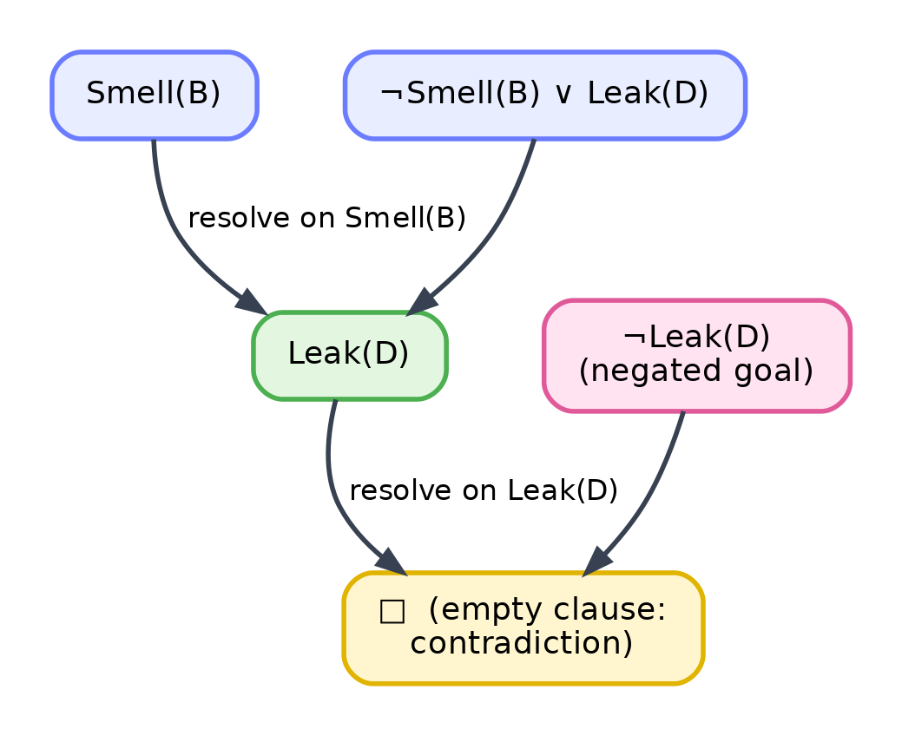
Figure 2.4. A resolution refutation. Resolving $Smell(B)$ with $¬Smell(B)∨Leak(D)$ yields $Leak(D)$. Resolving that with the negated goal $¬Leak(D)$ yields the empty clause, a contradiction, which proves the original goal $Leak(D)$.
Resolving the first two clauses on the pair $Smell(B)$ and $¬Smell(B)$ produces $Leak(D)$. Resolving that new clause with the negated goal $¬Leak(D)$ removes the last pair and leaves a clause with no literals at all. A clause with no literals is called the empty clause, written $▫$; it can never be true, so it signals a contradiction. The contradiction shows that assuming $¬Leak(D)$ was impossible, and therefore $Leak(D)$ follows. The robot has proved, by a purely mechanical procedure, where the leak is.
It is worth pausing on how much this resembles Chapter 1. Resolution repeatedly combines clauses, generating new ones, searching for the empty clause much as the earlier agent generated new states searching for a goal. The clauses are the states, the resolution rule is the action that produces successors, and the empty clause is the goal. Inference here is quite literally a search, now through a space of clauses rather than a space of map locations.

2.10 First-Order Logic
Propositional logic is precise, but it is also clumsy, and a small change to the reasoning world reveals why. Suppose the building had not four rooms but forty, and the rule “a room with no smell has no leaking neighbour” applied to all of them. In propositional logic this single idea would have to be written out separately for every room, forty near-identical sentences, and adding a room would mean adding more. The logic has no way to say “for every room” in one breath.
The same limitation appears with objects of any kind. To record that several people are students, propositional logic offers only a list of unrelated propositions.
Student(Amit)
Student(Riya)
Student(Rahul)
Each of these is, to propositional logic, an entirely separate atom with no connection to the others, and there is no way to state a rule about students in general. What is missing is the ability to talk about objects, about the properties they share, and about “all” and “some”. First-order logic supplies exactly this.
First-order logic adds several ingredients to the propositional picture. Objects are the things the logic talks about, such as the rooms A, B, C, D, or the people Amit and Riya. Constants are names for particular objects, such as $A$ or $Amit$. Variables are placeholders that can stand for any object, usually written with lowercase letters such as $x$ or $y$, and they are what allow general statements. Predicates express properties of objects or relationships among them, and each predicate becomes true or false once its objects are supplied; $Student(x)$ is a property, and $Adjacent(x,y)$ is a relationship between two objects. Functions name an object in terms of others, for instance a function that maps a room to the room north of it, though the reasoning world will not need them. Figure 2.5 shows a small collection of objects joined by relationships in this style.
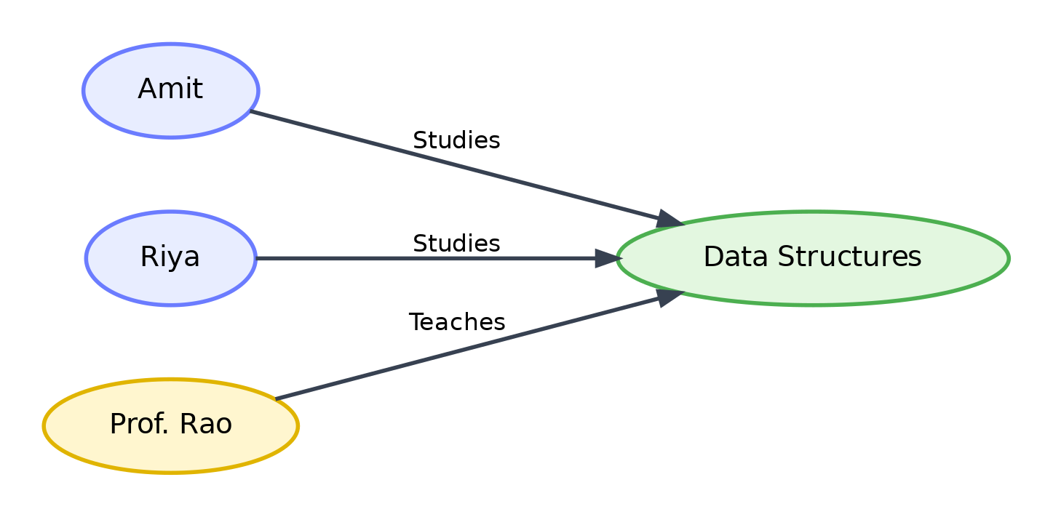
Figure 2.5. Objects and relationships in first-order logic. The objects Amit, Riya, and Prof. Rao are connected to the object Data Structures by the relationships Studies and Teaches. Each labelled arrow is a predicate applied to two objects.
With objects and predicates available, the reasoning world can be described compactly. The adjacency of rooms becomes a set of facts such as $Adjacent(A,B)$ and $Adjacent(B,D)$. The property of holding a leak becomes $Leak(x)$, and of smelling becomes $Smell(x)$. What is still missing is the ability to write a rule that ranges over all rooms at once, and that is the role of quantifiers.

2.11 Quantifiers
A quantifier states how many objects a statement applies to. Two are needed, and both can be understood before any symbol is introduced.
The first is the idea of “for all”. A statement may hold of every object in question, as in “every student studies”. The second is the idea of “there exists”. A statement may hold of at least one object, as in “some student is a topper”. These two, all and at least one, are the only quantities first-order logic needs, and every general statement is built from them.
The universal quantifier, written $∀$ and read “for all”, asserts that a statement holds for every object. “Every student studies” becomes $∀x (Student(x)→Studies(x))$, read as “for all $x$, if $x$ is a student then $x$ studies”. The existential quantifier, written $∃$ and read “there exists”, asserts that a statement holds for at least one object. “Some student is a topper” becomes $∃x (Student(x)∧Topper(x))$, read as “there exists an $x$ such that $x$ is a student and $x$ is a topper”. Figure 2.6 shows the difference: the universal statement colours every member of the set, while the existential statement colours only one.
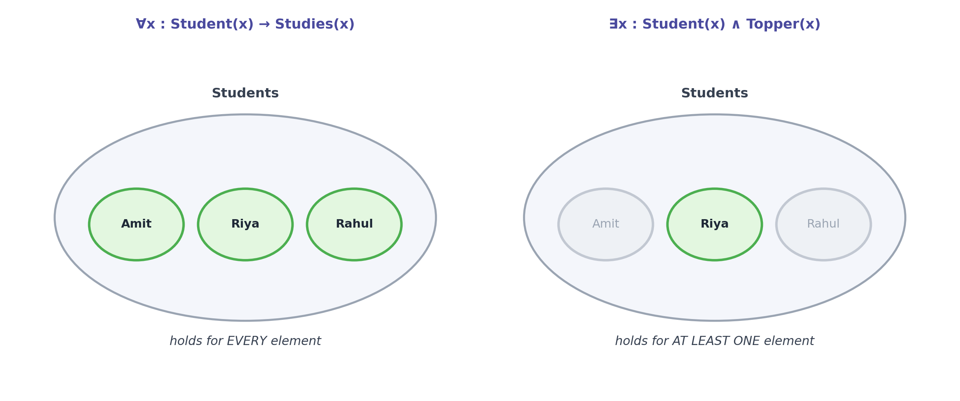
Figure 2.6. The two quantifiers over a small set of objects. A universal statement, on the left, must hold for every element. An existential statement, on the right, needs to hold for at least one element.
Two details cause most of the difficulty with quantifiers, and both deserve attention. The first is the pairing of quantifier with connective. A universal quantifier is almost always followed by an implication, as in $∀x (Student(x)→Studies(x))$, because the intention is to say something about students only, not about every object in the world. An existential quantifier is almost always followed by an and, as in $∃x (Student(x)∧Topper(x))$, because the intention is to claim that some object is both a student and a topper. Swapping these, using and with “for all” or implication with “there exists”, changes the meaning in ways that are usually not intended.
The second difficulty is the order of quantifiers, which is not free to rearrange. Compare two statements about people and their mothers. The sentence $∀x ∃y Mother(y,x)$ says that for every person there exists someone who is that person’s mother, which is true, and different people may have different mothers. The sentence $∃y ∀x Mother(y,x)$ says that there exists one person who is the mother of everyone, which is false. The words are the same and only the order differs, yet the meanings are entirely different. A universal followed by an existential lets the second choice depend on the first; an existential followed by a universal demands a single choice that works for all. Keeping this order in mind avoids a whole class of mistakes.
Negation of quantifiers follows a pattern that echoes De Morgan’s laws. Denying that a statement holds for all objects is the same as asserting that it fails for at least one, so $¬∀x P(x)$ is equivalent to $∃x ¬P(x)$. Denying that a statement holds for some object is the same as asserting that it fails for all, so $¬∃x P(x)$ is equivalent to $∀x ¬P(x)$. The negation moves inward and flips each quantifier to the other kind.

2.12 Using First-Order Logic
Reading and writing first-order logic fluently is a skill built by practice, so it helps to see everyday knowledge translated into it across several settings. In each case the movement is the same: an ordinary statement, its careful reading in English, its first-order form, and a note on what every symbol means.
Consider a university. The statement “every student who submits the assignment gets a grade” reads as “for every person, if that person is a student and submits the assignment, then that person gets a grade”, and becomes $∀x ((Student(x)∧Submits(x))→Graded(x))$. Here $x$ ranges over people, $Student$, $Submits$, and $Graded$ are properties, and the implication restricts the claim to students who submit.
Consider a hospital. The statement “some patient in the ward has a fever” reads as “there exists a person who is a patient in the ward and has a fever”, and becomes $∃x (Patient(x)∧Fever(x))$, where the existential quantifier and the and together assert that at least one object has both properties.
Consider road transport. The statement “every vehicle at the checkpoint must have a valid permit” becomes $∀x (Vehicle(x)∧AtCheckpoint(x)→HasPermit(x))$, a universal statement restricted by implication to vehicles that are at the checkpoint.
Consider the reasoning world once more, where quantifiers finally let its rules be written in full generality. The rule that a room without a smell has no leaking neighbour becomes
$$∀x (¬Smell(x)→∀y (Adjacent(x,y)→¬Leak(y))),$$
read as “for every room $x$, if $x$ has no smell, then for every room $y$ adjacent to $x$, room $y$ has no leak”. The rule that a smelly room has a leaking neighbour becomes
$$∀x (Smell(x)→∃y (Adjacent(x,y)∧Leak(y))),$$
read as “for every room $x$, if $x$ smells, then there exists a room $y$ adjacent to $x$ that has a leak”. Two sentences now capture what previously needed a separate rule for every room, and they would hold just as well for a building of forty rooms as for one of four. This economy is the reason first-order logic underlies most serious knowledge representation.

2.13 Inference in First-Order Logic
Adding variables and quantifiers makes the language far more expressive, but it also complicates inference, because the machine must now decide when a general rule applies to a particular fact. This raises a problem that did not exist in propositional logic.
Suppose the knowledge base contains the general fact that a certain relationship holds, written with a variable, and a specific fact written with a constant. To use the two together, the machine must recognise that the variable can stand for the constant. It must, in other words, find a way to make two expressions that look different describe the same thing. Doing this by eye is easy for a person and completely unclear to a machine, so a precise, mechanical method is needed. That method is substitution, and the procedure that finds the right substitution is unification.
A substitution is a set of replacements of variables by terms, written in braces, such as $\{x/Rahul\}$, which means “replace $x$ by $Rahul$”. Applying a substitution to an expression carries out those replacements. The reason substitution matters is that a general rule becomes usable only once its variables have been replaced by the particular objects at hand, and finding which replacement makes a rule match a fact is the heart of first-order inference.

2.14 Unification
Unification is the procedure that takes two expressions and finds a substitution making them identical, or reports that none exists. It is introduced most gently through an example.
Consider the two literals $Likes(x,Mango)$ and $Likes(Rahul,Mango)$. They are almost the same; the only difference is that the first has the variable $x$ where the second has the constant $Rahul$. Replacing $x$ by $Rahul$ makes them identical, so the substitution $\{x/Rahul\}$ unifies them. Figure 2.7 shows this alignment, argument by argument, alongside a case where unification fails.
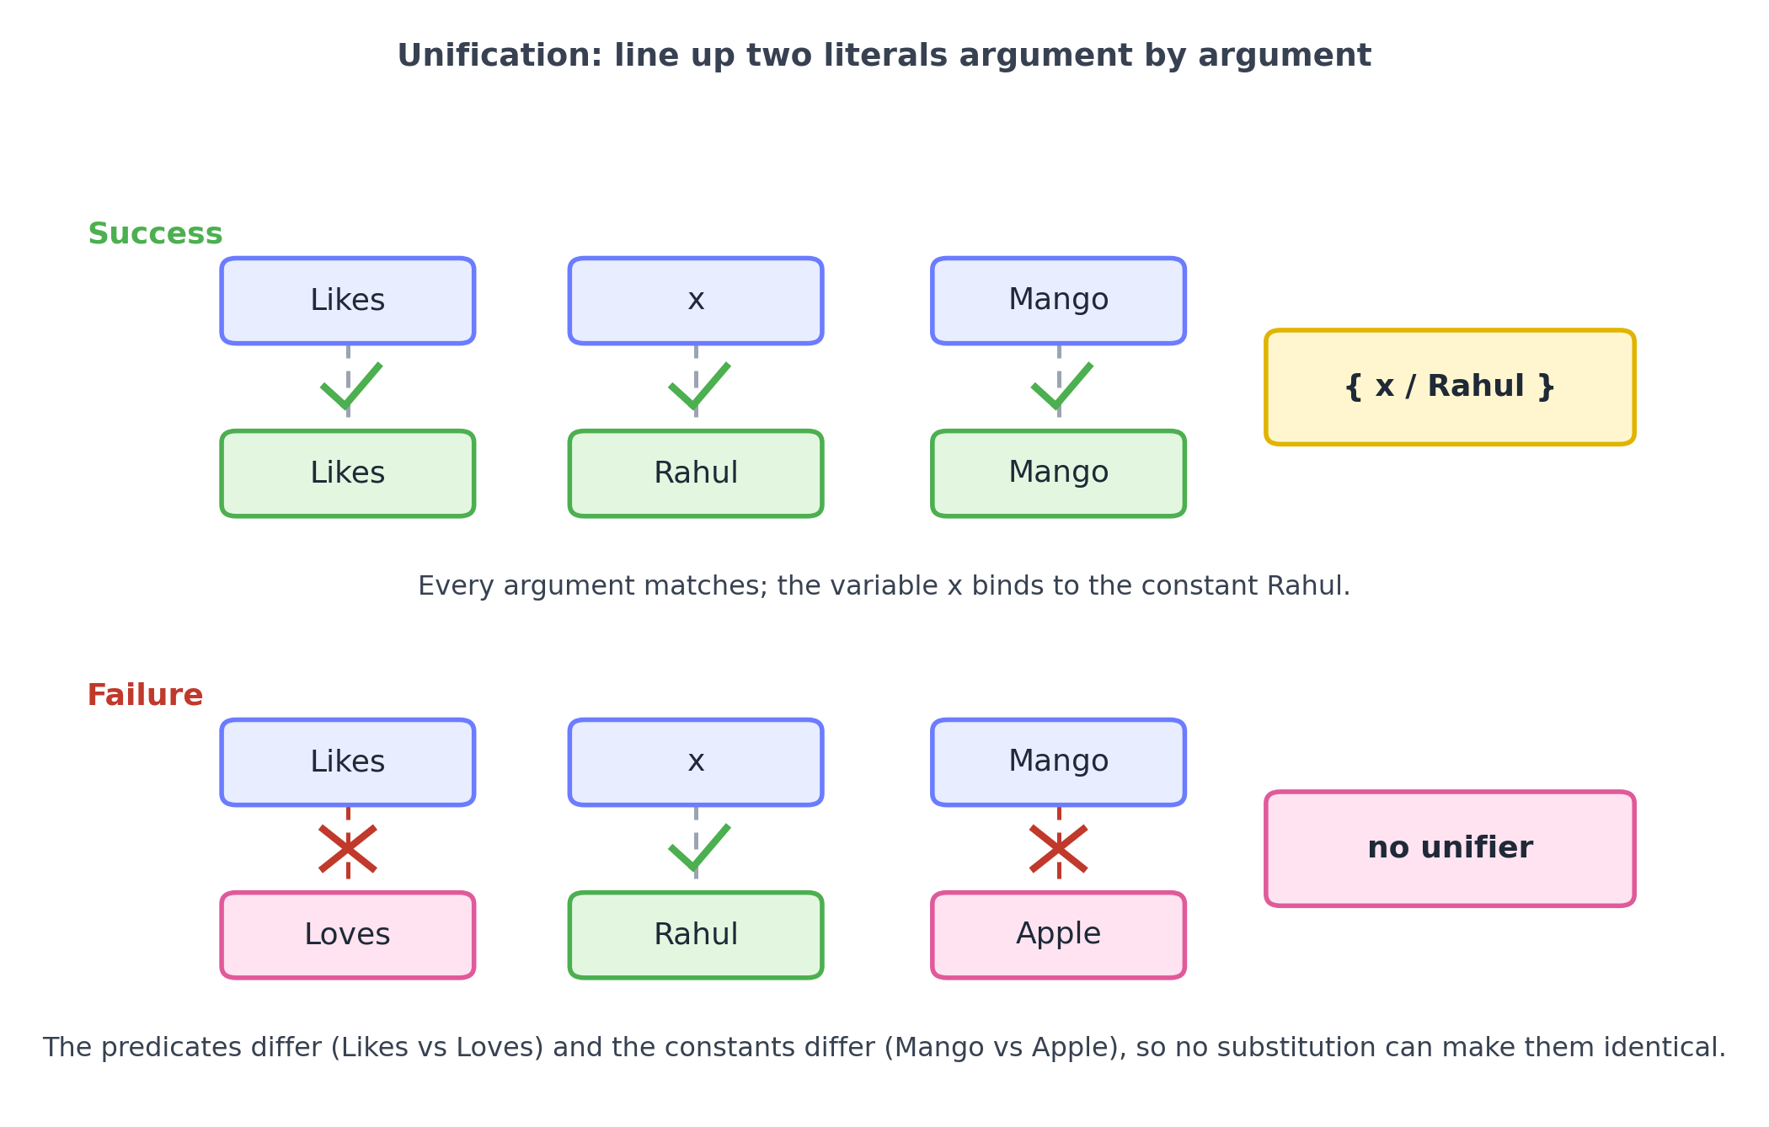
Figure 2.7. Unification lines up two literals argument by argument. On the top, every argument can be matched and the variable $x$ binds to $Rahul$, so a unifier exists. On the bottom, the predicates differ and two constants differ, so no substitution can make the literals identical and unification fails.
The vocabulary is small. A substitution, as above, is a set of variable replacements. A unifier of two expressions is a substitution that makes them identical. When several unifiers exist, one of them is the most general, meaning it commits to as little as possible, binding variables only where forced and leaving the rest free; this is called the most general unifier, abbreviated MGU. The most general unifier is preferred because it keeps the reasoning as flexible as possible, avoiding commitments that a more specific substitution would impose without reason.
A slightly harder example shows the procedure working step by step. To unify $Adjacent(B,y)$ with $Adjacent(B,D)$, compare the expressions position by position. The predicate names agree, both $Adjacent$. The first arguments agree, both the constant $B$. The second arguments are $y$ and $D$; since $y$ is a variable, bind it, adding $\{y/D\}$ to the substitution. No positions remain, so the two literals unify under $\{y/D\}$. Each step either matches two identical terms, binds a variable to a term, or fails.
Unification fails when no substitution can reconcile the expressions. It fails when the predicate names differ, as with $Likes$ and $Loves$, since no replacement of variables can change a predicate. It fails when two different constants are aligned, as with $Mango$ and $Apple$, since a constant cannot be replaced. Recognising these failures is as important as finding successes, because a reasoning system must not force a match that does not exist. This point returns among the misconceptions: unification is not ordinary equality, but the search for a substitution that would make two expressions equal.

2.15 Forward Chaining
Unification lets a single rule fire on particular facts. Chaining is what happens when many rules fire in sequence, each new fact enabling the next, and there are two directions in which this can proceed. The first is forward chaining.
Forward chaining starts from what is known and repeatedly applies rules to derive new facts, adding each to the knowledge base, until either the goal appears or no rule can produce anything new. It is data-driven: it pushes outward from the facts, following wherever the rules lead. The structure is a steady expansion.
known facts -> rules that match -> new facts -> more rules match -> ... -> goal
The reasoning world gives a clean example. Take the knowledge base to contain these facts and rules, where lowercase letters are variables and uppercase letters are particular rooms. The facts are that A has no smell, B smells, the adjacency of the rooms, and that the robot has visited A and B. The rules are that a visited room is safe, that a neighbour of a room with no smell is safe, and that a neighbour of a smelly room is a suspect worth inspecting.
Facts:
NoSmell(A), Smell(B)
Adjacent(A,B), Adjacent(A,C), Adjacent(B,A), Adjacent(B,D)
Visited(A), Visited(B)
Rules:
R1: Visited(x) -> Safe(x)
R2: NoSmell(r) AND Adjacent(r,s) -> Safe(s)
R3: Smell(r) AND Adjacent(r,s) -> Suspect(s)
Forward chaining proceeds as shown in Figure 2.8. Rule R1 fires on $Visited(A)$ and $Visited(B)$ to add $Safe(A)$ and $Safe(B)$. Rule R2 matches $NoSmell(A)$ with each neighbour of A, adding $Safe(B)$, already known, and $Safe(C)$, which is new. Rule R3 matches $Smell(B)$ with each neighbour of B, adding $Suspect(A)$ and $Suspect(D)$. No further rule produces anything new, so the process halts. The agent has learned that C is safe to enter and that D is a suspect to inspect, neither of which was among the original facts.
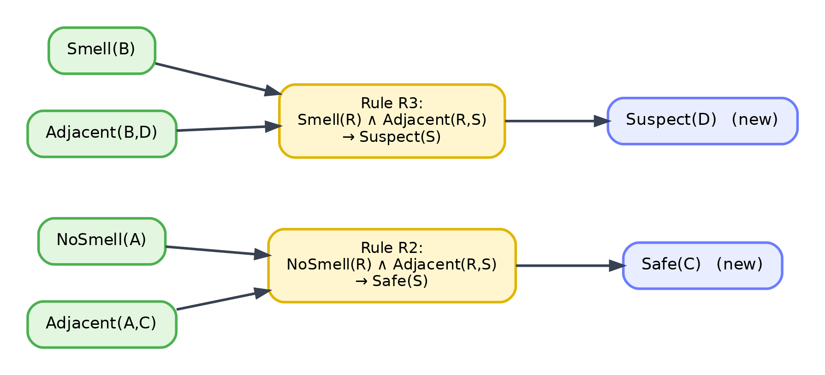
Figure 2.8. Forward chaining. Known facts flow into the rules whose conditions they satisfy, and each rule produces new facts. Here the facts about A and B produce the new conclusions $Safe(C)$ and $Suspect(D)$.
In outline, the procedure is simple to state.
repeat:
for each rule whose conditions all match known facts:
form the new fact from the rule's conclusion
if it is not already known, add it
until no new fact is added
Forward chaining has clear strengths and weaknesses. It is natural when new data arrives and the agent wants to know everything that now follows, which is why it suits monitoring and alerting systems that react to a stream of observations. Its weakness is that it derives every consequence of the facts, including many irrelevant to any particular question, which can be wasteful when only one specific conclusion is wanted. When the goal is narrow, the opposite direction is often better.

2.16 Backward Chaining
Backward chaining starts from the goal and works backward toward the facts. Rather than asking what the facts imply, it asks what would be needed to establish the goal, then what would be needed to establish those needs, and so on until the demands reduce to known facts. It is goal-driven.
goal -> rules that could prove it -> their conditions become subgoals -> ... -> known facts
Using the same knowledge base, suppose the agent wants to know whether room C is safe, that is, whether $Safe(C)$ can be proved. Backward chaining reasons as in Figure 2.9. The goal $Safe(C)$ matches the conclusion of rule R2 when $s$ is $C$, which turns the goal into two subgoals, that some room $r$ has no smell and that this $r$ is adjacent to C. The first subgoal, $NoSmell(r)$, is satisfied by the fact $NoSmell(A)$, binding $r$ to A. The second subgoal then becomes $Adjacent(A,C)$, which is a known fact. Both subgoals are met, so the original goal succeeds. The agent has proved $Safe(C)$ by tracing a path from the goal back to the facts that support it.
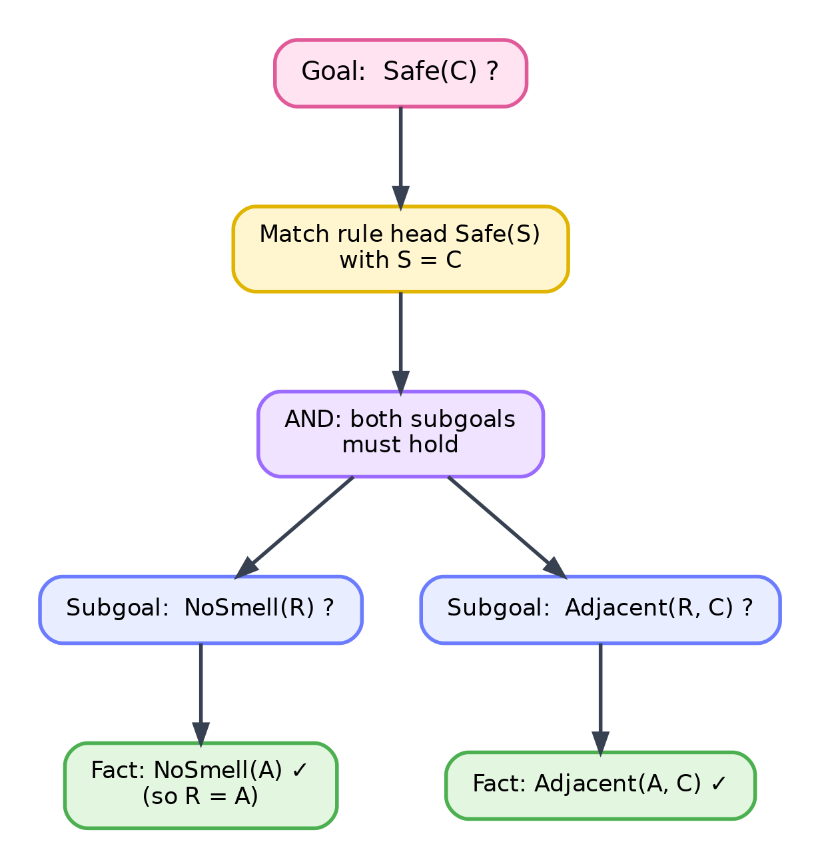
Figure 2.9. Backward chaining. The goal $Safe(C)$ is matched against a rule that could establish it, producing subgoals that are pursued in turn until each reduces to a known fact.
In outline, backward chaining is a recursive procedure.
to prove a goal:
if the goal is a known fact, succeed
otherwise, for each rule whose conclusion matches the goal:
try to prove each of the rule's conditions as a subgoal
if all conditions can be proved, succeed
if no rule works, fail
The connection to Chapter 1 is now direct and worth making explicit. Forward chaining searches outward from the known states, generating consequences much as breadth-first search generated successors, expanding steadily until the goal is met. Backward chaining searches from the target, breaking a goal into subgoals much as a problem is broken into smaller problems, pursuing one branch at a time in the manner of depth-first search. Both are systematic searches; they differ only in their starting point and direction, precisely the way the search strategies of Chapter 1 differed. Inference, once again, is search.

2.17 Forward and Backward Chaining Compared
The two strategies reach the same conclusions when a conclusion follows, but they explore the knowledge base in opposite ways, and each suits different circumstances. Figure 2.10 places them side by side.
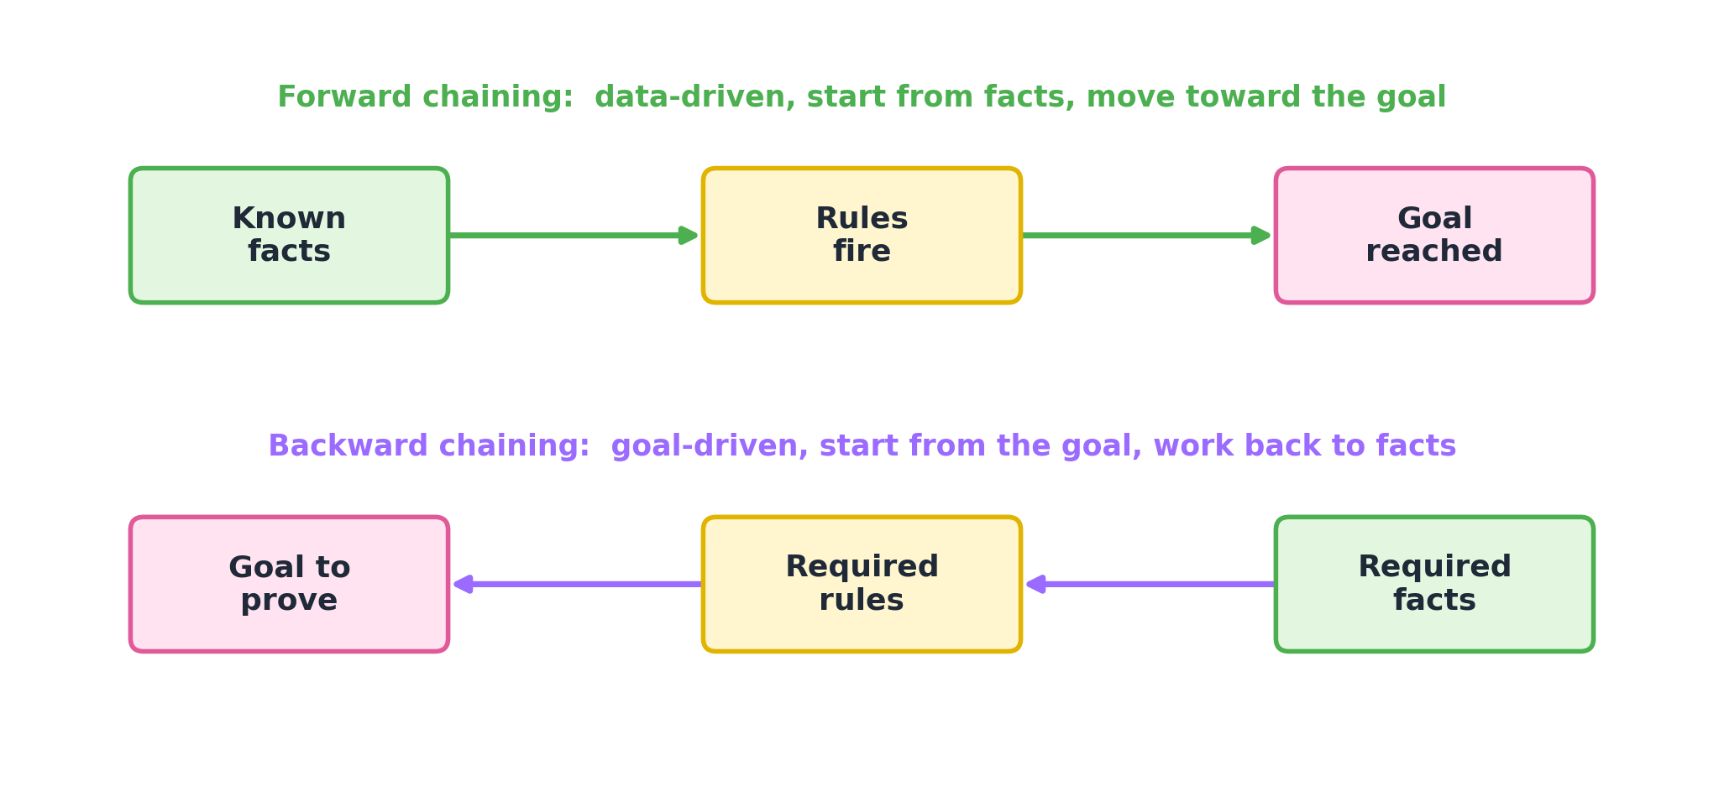
Figure 2.10. Forward chaining moves from known facts through rules toward the goal. Backward chaining moves from the goal through the rules it needs back to the facts that support it.
The differences are summarised below.
Aspect | Forward chaining | Backward chaining
Starting point | The known facts | The goal to prove
Direction | From facts toward the goal | From the goal toward facts
Style | Data-driven | Goal-driven
Search behaviour | Expands all consequences | Pursues only what the goal needs
Best when | Many facts, reacting to new data | A specific question to answer
Possible waste | Derives facts irrelevant to the goal | Re-explores subgoals if not remembered
Typical use | Monitoring and alerting | Question answering and diagnosis
Neither strategy is superior in every case. When observations stream in and the agent must keep its picture of the world current, forward chaining fits, because it naturally propagates the effects of each new fact. When a single precise question is asked, backward chaining fits, because it does only the work the question requires and ignores everything else. Systems that must do both often keep both strategies available and choose according to the task at hand.

2.18 A Small Reasoning System in Python
The ideas of this chapter can be turned into a short program, and doing so makes their workings unmistakable. The program below stores facts and rules, and provides both forward and backward chaining over them. It uses only ordinary Python, so that nothing is hidden inside a library. The knowledge base is the reasoning world from the previous sections, and the program’s output matches the reasoning done there by hand.
First, a fact is represented as a tuple whose first entry is a predicate name and whose remaining entries are its arguments, so that $Adjacent(A,B)$ becomes ("Adjacent", "A", "B"). A variable is written as a lowercase string such as "r", and a constant as a capitalised string such as "A". The single helper below decides which is which.
def is_var(t):
# A term is a variable if it is a string beginning with a lowercase letter.
return isinstance(t, str) and t[:1].islower()
Unification needs to look up what a variable currently stands for, following a chain of bindings if one variable was bound to another. The substitution is kept in a dictionary named s.
def walk(t, s):
# Follow the substitution until t is not a bound variable.
while is_var(t) and t in s:
t = s[t]
return t
The unifier compares two literals position by position. If the predicate names or the numbers of arguments differ, it fails. Otherwise it walks each pair of arguments; equal terms need nothing, a variable is bound to whatever it faces, and two differing constants cause failure.
def unify(x, y, s):
if s is None or x[0] != y[0] or len(x) != len(y):
return None # different predicate or arity: cannot match
s = dict(s) # copy so the caller's substitution is untouched
for a, b in zip(x[1:], y[1:]): # compare arguments one by one
a, b = walk(a, s), walk(b, s) # replace any already-bound variables
if a == b:
continue # identical terms: nothing to do
if is_var(a):
s[a] = b # bind variable a to term b
elif is_var(b):
s[b] = a # bind variable b to term a
else:
return None # two different constants: failure
return s
Applying a substitution to a term replaces each of its variables by what the substitution assigns.
def subst(term, s):
return tuple([term[0]] + [walk(a, s) for a in term[1:]])
Forward chaining needs to match all the conditions of a rule against the known facts at once, sharing bindings across them. The generator below yields every substitution under which a list of conditions all hold.
def match_all(premises, facts, s):
if not premises: # no conditions left: current bindings work
yield s; return
for fact in facts: # try to satisfy the first condition
s2 = unify(premises[0], fact, s)
if s2 is not None: # then satisfy the rest with those bindings
yield from match_all(premises[1:], facts, s2)
Forward chaining itself repeats over the rules, collecting every new fact each rule can produce, until a full pass adds nothing.
def forward_chain(facts, rules):
facts = set(facts)
changed = True
while changed:
changed = False
additions = set()
for premises, conclusion in rules:
for s in match_all(premises, facts, {}): # every way the rule fires
new = subst(conclusion, s) # the fact it concludes
if new not in facts:
additions.add(new)
if additions:
facts |= additions # add the new facts
changed = True # and go round again
return facts
Backward chaining works from a goal. It succeeds if the goal matches a known fact, or if some rule concludes the goal and all that rule’s conditions can themselves be proved. The generator threads bindings through the conditions so that a variable chosen for one condition keeps its value in the next.
def prove(goals, facts, rules, s):
if not goals: # nothing left to prove: success
yield s; return
goal, rest = subst(goals[0], s), goals[1:]
for fact in facts: # can the goal be met directly by a fact?
s2 = unify(goal, fact, s)
if s2 is not None:
yield from prove(rest, facts, rules, s2)
for premises, conclusion in rules: # or by a rule that concludes it?
s2 = unify(goal, conclusion, s)
if s2 is not None: # then its conditions become new goals
yield from prove(list(premises) + rest, facts, rules, s2)
def backward_chain(goal, facts, rules):
return any(True for _ in prove([goal], facts, rules, {}))
Finally, the reasoning world is entered and both procedures are run.
facts = [
("NoSmell", "A"), ("Smell", "B"),
("Adjacent", "A", "B"), ("Adjacent", "A", "C"),
("Adjacent", "B", "A"), ("Adjacent", "B", "D"),
("Visited", "A"), ("Visited", "B"),
]
rules = [
([("Visited", "x")], ("Safe", "x")),
([("NoSmell", "r"), ("Adjacent", "r", "s")], ("Safe", "s")),
([("Smell", "r"), ("Adjacent", "r", "s")], ("Suspect", "s")),
]
derived = forward_chain(facts, rules)
print(sorted(f for f in derived if f[0] == "Safe"))
print(sorted(f for f in derived if f[0] == "Suspect"))
print(backward_chain(("Safe", "C"), facts, rules))
print(backward_chain(("Safe", "D"), facts, rules))
Running the program prints the safe rooms as A, B, and C, the suspects as A and D, then True for the query whether C is safe and False for the query whether D is safe. These match the reasoning done by hand: C was shown safe, and D, the suspected leak, was never shown safe. The whole of this chapter’s reasoning, from facts and rules to derived conclusions in both directions, fits in a page of ordinary code.

2.19 Where Knowledge and Reasoning Appear
Reasoning of this kind is not confined to a toy building. Systems that store rules and derive conclusions from them are widely used, and in each case the value lies in the reasoning step, not merely in the storage of facts.
The oldest and clearest application is the expert system, a program that captures the rules a human specialist would apply and uses them to reach conclusions in a narrow domain. In medical decision support, a knowledge base holds rules connecting symptoms, test results, and conditions, and given a particular patient’s findings it derives the conditions consistent with them, much as the robot derived the location of the leak, offering a clinician a shortlist to consider. In fault diagnosis for machinery or networks, rules connect observable symptoms, an overheating part, a dropped connection, to underlying causes, and the system reasons from the symptoms an operator reports to the likely fault, narrowing a search that would otherwise be manual.
Rule-based reasoning also underlies many everyday services. In fraud detection for digital payments, rules encode patterns that indicate risk, an unusual amount, an unfamiliar location, a rapid sequence of transactions, and the system reasons from a transaction’s features to a judgement of whether it should be flagged. In eligibility systems used by governments and institutions, rules encode the conditions for a benefit or an admission, and the system reasons from an applicant’s details to a decision, applying the same rule uniformly to everyone. In configuration systems, rules encode which components fit together, and the system reasons from a customer’s requirements to a valid configuration, ruling out combinations that cannot work.
More recent forms of the same idea appear in knowledge graphs, large collections of objects and relationships of the kind first-order logic describes, over which systems reason to answer questions and to infer relationships that were never stated explicitly. When a search service answers a question by combining several stored relationships, or a smart-home controller decides to switch on a light because it has inferred that a room is occupied after dark, the underlying pattern is the same one built in this chapter: facts and rules, combined by inference, yielding conclusions that were never stored. Across all of these, the reasoning is what earns the name intelligent; storage alone would only return what was already known.

2.20 Common Misconceptions
Several misunderstandings recur when these ideas are first met, and naming them plainly is the surest way to avoid them.
The belief that implication means causation reads too much into the arrow. The sentence $P→Q$ only rules out the case where $P$ holds and $Q$ fails; it says nothing about $P$ bringing $Q$ about. Rain and wet ground may satisfy an implication in either direction without one causing the other in the logical sense.
The belief that $P→Q$ asserts that both $P$ and $Q$ are true misreads the connective. The implication makes a claim only when $P$ is true; when $P$ is false the implication is automatically true, and it never by itself asserts that $P$ holds at all.
The belief that the two quantifiers are interchangeable ignores their different force. “For all” claims something of every object, while “there exists” claims something of at least one, and the order in which they appear changes meaning further, as the example of mothers showed. Swapping them, or reordering them, generally produces a different and often false statement.
The belief that propositional logic can represent anything naturally underestimates how quickly it becomes unwieldy. It cannot say “for every room” in one sentence, so any statement about many objects must be spelled out object by object, which is why first-order logic exists.
The belief that inference and implication are the same thing confuses a connective with a process. Implication is a symbol inside a sentence; inference is the activity of deriving new sentences from old. A knowledge base contains implications, and inference is what the agent does with them.
The belief that forward and backward chaining are meant for different kinds of logic mistakes a choice of direction for a difference in subject. Both operate on the same rules and facts; they differ only in whether they start from the facts or from the goal.
The belief that unification is ordinary equality misses its purpose. Two literals need not be equal to unify; unification looks for a substitution that would make them equal, and reports failure only when no such substitution exists.
The belief that a knowledge base is just a database overlooks the reasoning step. A database returns what was stored; a knowledge base returns what follows from what was stored, which may be a great deal more.
The belief that a logically valid conclusion is necessarily true in the real world confuses validity with truth. A conclusion validly derived is true whenever the premises are true, but if a premise is mistaken, the conclusion may be false in fact while remaining validly derived. Sound reasoning guarantees correctness only to the extent that the knowledge it starts from is correct.

2.21 Questions to Test Understanding
The following questions capture the ideas most worth being able to explain in one’s own words, with concise answers.
What is a knowledge-based agent? It is an agent whose actions are chosen by reasoning over a stored body of knowledge, rather than by fixed instructions alone. It repeatedly perceives, adds what it perceives to its knowledge base, asks the base for what follows, infers new facts in the process, and acts.
How does a knowledge base differ from a database? A database returns exactly the facts stored in it. A knowledge base holds facts and rules and, when queried, returns conclusions that were never stored, by combining what it holds through inference.
What is inference, and how does it relate to entailment? Entailment is the relationship that holds when a conclusion is true in every model of the premises, a statement about truth. Inference is the mechanical process of deriving conclusions from premises. A sound inference procedure derives only entailed conclusions; a complete one derives all of them.
What is the difference between propositional and first-order logic? Propositional logic reasons about whole statements that are simply true or false. First-order logic adds objects, predicates that express their properties and relationships, and quantifiers that let a single sentence speak about all objects or some object, which propositional logic cannot do.
Why are quantifiers needed? Without them, a statement about many objects must be written separately for each object. Quantifiers let one sentence assert something of every object or of at least one, which is essential for general knowledge.
What is unification, and what is a most general unifier? Unification finds a substitution that makes two expressions identical, or reports that none exists. The most general unifier is the one that commits to as little as possible, binding variables only where forced, which keeps later reasoning as flexible as possible.
How do forward and backward chaining differ? Forward chaining starts from the known facts and derives consequences until the goal appears, which suits reacting to incoming data. Backward chaining starts from the goal and reduces it to subgoals until they meet known facts, which suits answering a specific question.
Why can inference be considered a form of search? Because deriving a conclusion means exploring a space of possibilities, clauses to resolve, rules to apply, substitutions to try, moving step by step toward a target, exactly as the search of Chapter 1 explored states and actions toward a goal.

2.22 Exercises
The exercises are arranged so that the earliest test basic recall, the middle ones ask you to apply a method, and the last ones ask you to reason about ideas. Each exercise is self-contained: any knowledge base or set of clauses it needs is stated with the question. Worked solutions follow in the next section, and each solution shows the steps, not only the final answer.
Group A. Basic recall
- Write the full truth table for $P→Q$, and state the one row in which it is false.
- Translate the sentence “there is a smell in B and the leak is not in A” into propositional logic.
- In one sentence each, explain the difference between a fact, a rule, and a model.
- Rewrite the rule $Smell(B)→Leak(D)$ as a single clause, using only negation and or.
Group B. Applying a method
- Decide whether $¬(P∧Q)$ and $¬P∨¬Q$ are logically equivalent by building and comparing their truth tables.
- Translate the sentence “every patient in the ward who has a fever is given medicine” into first-order logic.
- Find the most general unifier of $Adjacent(x,D)$ and $Adjacent(B,y)$, or explain why none exists.
- A knowledge base contains the facts $NoSmell(A)$, $Smell(B)$, the adjacencies $Adjacent(A,B)$, $Adjacent(A,C)$, $Adjacent(B,A)$, $Adjacent(B,D)$, and $Visited(A)$, $Visited(B)$. Its rules are R1: $Visited(x)→Safe(x)$; R2: $NoSmell(r)∧Adjacent(r,s)→Safe(s)$; and R3: $Smell(r)∧Adjacent(r,s)→Suspect(s)$. List every new fact that forward chaining derives, and name the rule that produces each.
Group C. Advanced reasoning
- Prove $Leak(D)$ by resolution from the two clauses $Smell(B)$ and $¬Smell(B)∨Leak(D)$. Show every step, including the negated goal and the empty clause.
- Give a small example showing that $∀x ∃y P(x,y)$ and $∃y ∀x P(x,y)$ can have different truth values, and explain why.
- Convert $¬(P→Q)$ into conjunctive normal form, and justify each step by naming the equivalence used.
Group D. Conceptual and applied
- A monitoring system receives a continuous stream of sensor readings and must always know everything that currently follows from them. Would forward or backward chaining suit it better, and why?
- Describe how a rule-based fraud-detection system reasons from the features of a single transaction to a decision, and identify which step in the process is the inference.
- Explain why a conclusion that is validly derived can still be false in the real world, and what this implies about the knowledge an agent is given.

Solutions
Each solution names the idea it uses, works through the steps, and states the final answer in bold.
Solution 1. The question asks for the complete truth table of the implication $P→Q$ and for the case where it fails. The rule for implication, from Section 2.5, is that $P→Q$ is false only when the condition $P$ is true while the conclusion $Q$ is false; in every other case it is true. Writing out all four combinations of the two propositions gives the table below.
P | Q | P → Q
true | true | true
true | false | false
false | true | true
false | false | true
Answer: the implication is false only in the second row, where $P$ is true and $Q$ is false. This matches the idea that a promise “if $P$ then $Q$” is broken only when $P$ happens but $Q$ does not.
Solution 2. The task is to turn an English sentence into propositional logic. Two connective words appear: “and”, which becomes $∧$, and “not”, which becomes $¬$. The sentence has two parts, “there is a smell in B”, written $Smell(B)$, and “the leak is not in A”, written $¬Leak(A)$, joined by “and”. Answer: $Smell(B)∧¬Leak(A)$.
Solution 3. This is a definition question drawing on Section 2.4. A fact is a statement taken to be true in the situation at hand, such as “there is no smell in A”. A rule is a general statement that lets one fact produce another, such as “if a room has no smell, its neighbours have no leak”. A model is one complete assignment of true or false to every basic statement, that is, one entire way the world could be.
Solution 4. The goal is to rewrite an implication as a clause, meaning a group of literals joined by or. The relevant equivalence, from Section 2.7, is the implication law $P→Q≡¬P∨Q$: an “if, then” can always be rewritten as “not the condition, or the conclusion”. Applying it with $P=Smell(B)$ and $Q=Leak(D)$ replaces the arrow directly. Answer: $¬Smell(B)∨Leak(D)$.
Solution 5. The question asks whether two sentences are logically equivalent, which by the definition in Section 2.7 means having the same truth value in every case. The way to check is to build one truth table holding both sentences and compare their final columns. Working outward from the atoms $P$ and $Q$, first form $P∧Q$ and then negate it, and separately form $¬P$, $¬Q$, and their or.
P | Q | P ∧ Q | ¬(P ∧ Q) | ¬P | ¬Q | ¬P ∨ ¬Q
true | true | true | false | false | false | false
true | false | false | true | false | true | true
false | true | false | true | true | false | true
false | false | false | true | true | true | true
The column for $¬(P∧Q)$ reads false, true, true, true, and the column for $¬P∨¬Q$ reads exactly the same. Answer: the two sentences are logically equivalent. This is one of De Morgan’s laws: denying that two things both hold is the same as saying at least one of them fails.
Solution 6. The task is to express a general statement about all patients, which calls for the universal quantifier $∀$ from Section 2.11. A universal statement is almost always paired with an implication, so that the claim applies only to the intended objects rather than to everything. The sentence restricts attention to a person who is a patient, is in the ward, and has a fever, and asserts that such a person is given medicine. Using the predicates $Patient$, $InWard$, $Fever$, and $GivenMedicine$, the three conditions are joined by and and placed before the arrow. Answer: $∀x ((Patient(x)∧InWard(x)∧Fever(x))→GivenMedicine(x))$.
Solution 7. The question asks for the most general unifier of two literals, that is, the substitution that makes them identical while binding as few variables as possible (Section 2.14). Unification proceeds by comparing the literals position by position. The predicate names agree, both $Adjacent$. The first arguments are $x$ and $B$; since $x$ is a variable, bind it, giving $\{x/B\}$. The second arguments are $D$ and $y$; since $y$ is a variable, bind it, giving $\{y/D\}$. No positions remain. Answer: the most general unifier is $\{x/B, y/D\}$, under which both literals become $Adjacent(B,D)$.
Solution 8. This asks us to run forward chaining, which starts from the known facts and applies each rule whose conditions are all satisfied, adding any new fact it produces (Section 2.15). We take the three rules in turn.
Rule R1, $Visited(x)→Safe(x)$, matches the facts $Visited(A)$ and $Visited(B)$, producing $Safe(A)$ and $Safe(B)$.
Rule R2, $NoSmell(r)∧Adjacent(r,s)→Safe(s)$, matches $NoSmell(A)$ together with each room adjacent to A. Since $Adjacent(A,B)$ and $Adjacent(A,C)$ hold, it produces $Safe(B)$, which is already known, and $Safe(C)$, which is new.
Rule R3, $Smell(r)∧Adjacent(r,s)→Suspect(s)$, matches $Smell(B)$ together with each room adjacent to B. Since $Adjacent(B,A)$ and $Adjacent(B,D)$ hold, it produces $Suspect(A)$ and $Suspect(D)$.
No further rule produces anything new, so the process stops. Answer: the new facts derived are $Safe(A)$ and $Safe(B)$ by R1, $Safe(C)$ by R2, and $Suspect(A)$ and $Suspect(D)$ by R3.
Solution 9. The goal is to prove $Leak(D)$ by resolution, which works by refutation: assume the opposite of the goal and derive the empty clause, a contradiction (Section 2.9). We begin with three clauses: the fact $Smell(B)$; the rule as a clause, $¬Smell(B)∨Leak(D)$; and the negated goal, $¬Leak(D)$.
Step 1: resolve $Smell(B)$ with $¬Smell(B)∨Leak(D)$. These share the opposed pair $Smell(B)$ and $¬Smell(B)$; cancelling that pair leaves the new clause $Leak(D)$.
Step 2: resolve $Leak(D)$ with the negated goal $¬Leak(D)$. These are an opposed pair; cancelling them leaves a clause with no literals at all, the empty clause $▫$.
The empty clause can never be true, so it signals a contradiction. Answer: the assumption $¬Leak(D)$ leads to a contradiction, so $Leak(D)$ must be true, which proves the goal.
Solution 10. The question is why the order of two quantifiers matters (Section 2.11). Let $P(x,y)$ mean “$y$ is a parent of $x$”. Reading the first sentence, $∀x ∃y P(x,y)$ says that for every person there exists someone who is their parent; different people may have different parents, and this is true. Reading the second, $∃y ∀x P(x,y)$ says that there exists one single person who is the parent of everybody, which is false. Answer: the sentences differ in truth value because a universal followed by an existential lets the second choice depend on the first, while an existential followed by a universal demands one fixed choice that works for all; only the order of the quantifiers has changed.
Solution 11. The task is to convert a sentence to conjunctive normal form, meaning a collection of clauses, using the equivalences of Section 2.7 and justifying each step.
Step 1: start with $¬(P→Q)$.
Step 2: remove the implication using $P→Q≡¬P∨Q$, giving $¬(¬P∨Q)$.
Step 3: push the negation inward using De Morgan’s law $¬(X∨Y)≡¬X∧¬Y$, giving $¬(¬P)∧¬Q$.
Step 4: simplify the double negation using $¬(¬P)≡P$, giving $P∧¬Q$.
Answer: the conjunctive normal form is $P∧¬Q$, which is two single-literal clauses, $P$ and $¬Q$, joined by and.
Solution 12. This asks which chaining direction suits a system that must always know all current consequences of incoming data (Section 2.16). Forward chaining is data-driven: it starts from the facts and derives everything that follows. Backward chaining is goal-driven: it works from a specific question back to the facts. Because the monitoring system has no single fixed question and must keep its whole picture up to date as each reading arrives, deriving all consequences forward from the new facts is exactly the right behaviour, whereas backward chaining would have to re-derive from the goal for every possible question. Answer: forward chaining suits it better, because it propagates the consequences of each new fact as the fact arrives.
Solution 13. The question asks how a rule-based fraud-detection system reaches a decision and which step is the inference. The system holds rules linking transaction features, such as an unusual amount, an unfamiliar location, or rapid repetition, to a judgement of risk. Given one transaction, it checks which rules the transaction’s features satisfy and combines them to reach a conclusion, flagged or not flagged. Answer: the inference is the step that combines the transaction’s features with the rules to derive the risk judgement; simply storing the features would decide nothing, so it is the reasoning over the rules, not the storage, that produces the decision.
Solution 14. This asks why a valid derivation can still give a false conclusion. A valid derivation guarantees only that the conclusion is true whenever the premises are true; it says nothing about whether the premises themselves are true. If a premise the agent was given is mistaken, the conclusion can be correctly derived yet false in fact. Answer: correctness in the real world depends on two things together, sound inference and accurate starting knowledge, so an agent that reasons flawlessly from wrong facts can still reach a wrong conclusion.

2.23 Summary
An agent that can only search, as in Chapter 1, cannot combine facts to reach conclusions it was never told. This chapter added that ability. A knowledge-based agent holds a knowledge base of sentences and works in a cycle: it perceives, tells the base what it saw, asks the base a question, infers what follows, and acts. A knowledge base differs from a database precisely in that inference step, returning what follows from the stored knowledge rather than only what was stored.
To reason mechanically, knowledge must be written in a precise language. Propositional logic supplies one, with atomic propositions combined by the connectives not, and, or, implies, and if and only if, each fixed by a truth table. Truth tables, generated by listing all $2^{n}$ combinations of the atoms, evaluate any sentence and reveal which worlds it rules out. Logical equivalences, including the implication law and De Morgan’s laws, let sentences be rewritten without changing their meaning. Entailment is the relationship that holds when a conclusion is true in every model of the premises, and inference is the process of deriving such conclusions, judged by soundness, deriving only what is entailed, and completeness, deriving all of it. Modus ponens is one sound step; resolution is a general, mechanical method that proves a goal by assuming its negation and deriving the empty clause, working on sentences in conjunctive normal form.
Propositional logic cannot speak of many objects at once, so first-order logic adds objects, constants, variables, predicates for properties and relationships, and the quantifiers “for all” and “there exists”. Quantifiers let a single sentence state a general rule, but their pairing with connectives and their order must be handled with care. Applying general rules to particular facts requires substitution, and unification is the procedure that finds a substitution making two expressions identical, preferring the most general one. Chaining applies rules in sequence: forward chaining pushes outward from the facts, while backward chaining works back from the goal. Both are systematic searches, differing only in direction, which returns to the chapter’s central theme that inference is itself a form of search, now through statements, rules, and substitutions rather than through states on a map.

2.24 Key Takeaways
A knowledge-based agent reasons over stored knowledge rather than following fixed instructions, and its cycle is perceive, tell, ask, infer, act. A knowledge base returns what follows from its contents, not merely what was stored. Propositional logic fixes the meaning of five connectives through truth tables, and entailment means truth in every model of the premises. Inference is judged by soundness and completeness, and resolution is a general method that proves a goal by deriving a contradiction from its negation. First-order logic adds objects, predicates, and the quantifiers “for all” and “there exists”, making general knowledge expressible. Unification finds the substitution that makes two expressions match. Forward and backward chaining apply rules from the facts forward or from the goal backward, and both are forms of search, the thread that ties this chapter to the last.

2.25 Quick Revision
- A knowledge-based agent perceives, tells its knowledge base, asks it, infers, and acts.
- A knowledge base differs from a database by returning what follows, not only what was stored.
- Propositional connectives: not $¬$, and $∧$, or $∨$, implies $→$, if and only if $↔$.
- $P→Q$ is false only when $P$ is true and $Q$ is false.
- A truth table over $n$ atoms has $2^{n}$ rows.
- Useful equivalences: $P→Q≡¬P∨Q$; De Morgan’s $¬(P∧Q)≡¬P∨¬Q$ and $¬(P∨Q)≡¬P∧¬Q$.
- Entailment ($⊨$) means the conclusion is true in every model of the premises.
- Sound inference derives only entailed conclusions; complete inference derives all of them.
- Modus ponens: from $P$ and $P→Q$, conclude $Q$.
- Resolution proves a goal by adding its negation and deriving the empty clause $▫$, working in conjunctive normal form.
- First-order logic adds objects, constants, variables, predicates, and the quantifiers $∀$ and $∃$.
- $∀$ usually pairs with $→$; $∃$ usually pairs with $∧$; quantifier order changes meaning.
- Unification finds a substitution making two expressions identical; the most general unifier commits to the least.
- Forward chaining runs from facts to goal; backward chaining runs from goal to facts; both are search.

2.26 Logic and Rule Reference
Symbol or term | Meaning
¬P | not P; true when P is false
P ∧ Q | P and Q; true when both hold
P ∨ Q | P or Q; true when at least one holds
P → Q | if P then Q; false only when P holds and Q fails
P ↔ Q | P if and only if Q; true when both have the same value
⊨ | entailment; the conclusion holds in every model of the premises
≡ | logical equivalence; the same truth value in every case
∀x | for all x
∃x | there exists an x
{ x / A } | substitution replacing the variable x by A
□ | the empty clause, signalling a contradiction
Modus ponens | from P and P → Q, infer Q
Resolution | cancel an opposed pair of literals from two clauses to form a new clause
Forward chaining | derive consequences from facts until the goal appears
Backward chaining | reduce a goal to subgoals until they meet known facts

2.27 Concept Map
The chapter’s ideas connect as shown in Figure 2.11. Knowledge and reasoning sit at the centre, surrounded by the knowledge-based agent that uses them, the two logics that express them, the inference that draws conclusions, the two directions of chaining, and the links outward to other topics.
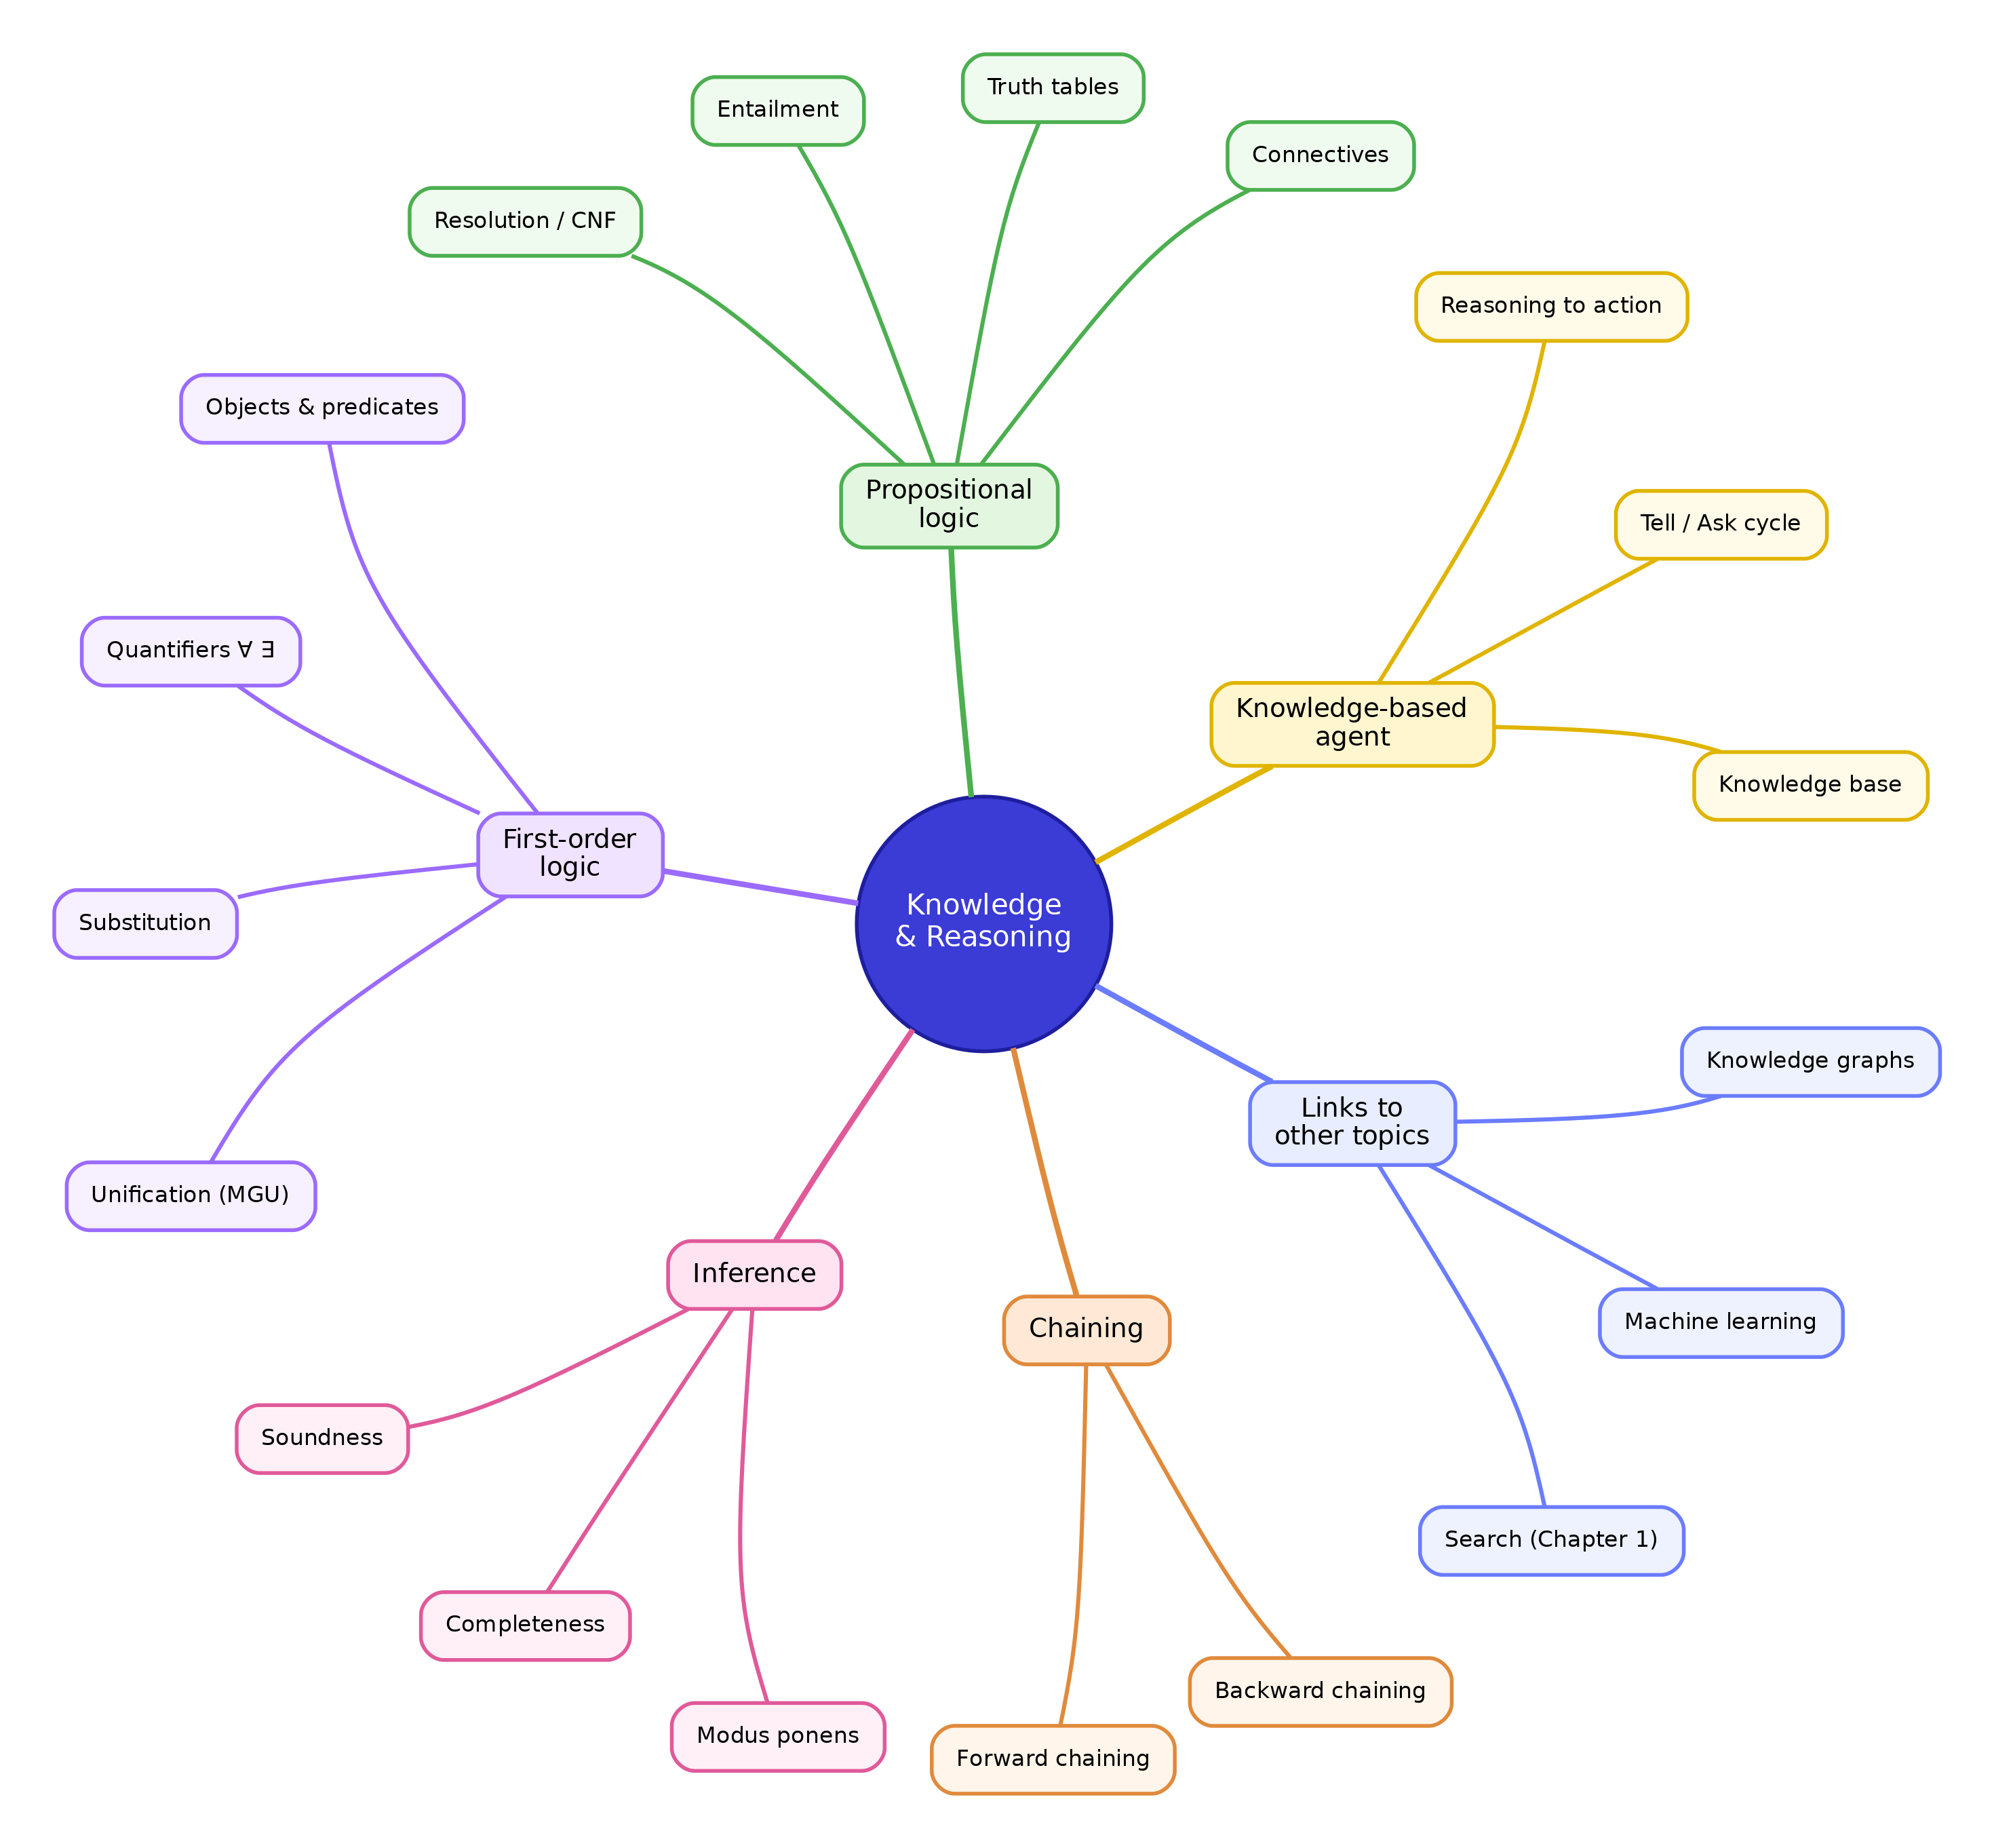
Figure 2.11. A concept map of the chapter, linking the knowledge-based agent, propositional and first-order logic, inference, and the two forms of chaining, with connections outward to the search of Chapter 1 and to later topics.
The connections outward are worth stating plainly. The search of Chapter 1 returns here as the engine of inference, since resolution and chaining are searches through clauses and rules rather than through states on a map. The knowledge and rules of this chapter reappear in later study as knowledge graphs, large structured collections of objects and relationships reasoned over at scale. And the reasoning developed here sits beside the learning of the chapters to come, where instead of being given rules an agent will discover them from data, the natural next question once an agent can reason with rules it already holds.

2.28 Glossary
Term | Meaning
Knowledge-based agent | An agent that chooses actions by reasoning over a stored knowledge base.
Knowledge base | A collection of sentences, both facts and rules, that an agent can reason over.
Tell | The operation of adding a sentence to the knowledge base.
Ask | The operation of querying the knowledge base, possibly requiring inference.
Fact | A statement taken to be true in the current situation.
Rule | A general statement that lets one fact yield another.
Model | One complete assignment of true or false to every basic statement; one possible world.
Interpretation | The meaning attached to the symbols of a logical language.
Entailment | The relationship holding when a conclusion is true in every model of the premises.
Inference | The process of deriving conclusions from premises.
Soundness | The property of deriving only conclusions that are entailed.
Completeness | The property of deriving every conclusion that is entailed.
Proposition | A statement that is either true or false.
Atomic proposition | A proposition that cannot be broken into smaller statements.
Compound proposition | A proposition built from atomic ones using connectives.
Connective | A symbol combining propositions: not, and, or, implies, if and only if.
Truth table | A listing of a sentence’s value for every combination of its atoms.
Logical equivalence | The relationship holding when two sentences share the same value in every case.
Modus ponens | The inference from P and (P → Q) to Q.
Literal | An atomic proposition or its negation.
Clause | A group of literals joined by or.
Conjunctive normal form | A collection of clauses joined by and.
Resolution | An inference method that cancels an opposed pair of literals from two clauses.
Empty clause | A clause with no literals, signalling a contradiction.
First-order logic | A logic with objects, predicates, and quantifiers, extending propositional logic.
Constant | A name for a particular object.
Variable | A placeholder that can stand for any object.
Predicate | A symbol expressing a property of, or relationship among, objects.
Quantifier | A symbol stating how many objects a statement applies to: ∀ or ∃.
Universal quantifier | The quantifier ∀, asserting a statement holds for every object.
Existential quantifier | The quantifier ∃, asserting a statement holds for at least one object.
Substitution | A set of replacements of variables by terms.
Unification | The procedure that finds a substitution making two expressions identical.
Most general unifier | The unifier that commits to as little as possible.
Forward chaining | Inference from known facts toward the goal.
Backward chaining | Inference from the goal back toward known facts.
The next chapter takes the natural step beyond reasoning with given rules. Instead of supplying an agent with the rules it needs, it lets the agent learn them from examples, and the question shifts from what follows from what we know to how knowledge itself can be acquired from experience.

